# Portfolio Requirements

Each portfolio must:

1. Have at least three "pages." These can be three different html files, or one file that links to all three "pages". Here is an example:

Single file: Clicking on the navigation links will take you to a specific section in a page.

<http://winespto.org/> (Note, this page may take some time to load. This is due to the donation plug-in.)

Multiple files: Clicking on the navigation links will take you to a different file

<http://www.intro-webdesign.com/>

As you make your choice, think about any accessibility issues that may come along with your implementation. You will not have time to make a "perfect" site (no one ever does), but I am concerned with you making informed decisions.

* Each page must have at least two semantic tags (header, nav, footer, etc)
* Each page must validate at validator.w3.org.
* Each page must be responsive -- there must be at least two unique views
* You must have at least 4 images on one of your pages. (If this requirement doesn't "fit" your portfolio plan, please just make an extra page that fulfills it. You can always unlink it after you have been peer -graded.
* Each page must be styled. The goal is not to impress, but to show competence. So add enough to show that you know how to write CSS rules. But peer-review with the knowledge that not everything will be beautiful.

# Portfolio Grading Rubric

I hope that people will be more concerned with their learning than their grade on this assignment. But I understand that people want to make sure they receive full credit so I will provide the grading rubric that will be used. Feel free to structure your page around it.

1. Does the site validate? 10pts
2. Is the site responsive? 20pts
3. Is the site well-styled? 10pts
4. Are the images incorporated effectively? 5pts
5. Successfully demonstrated the ability to enhance their site? 40pts

### Does the site validate?

* 10pts – Fully validates (warnings are fine)
* 8 pts – There are errors, but the student has shown (in their write-up or video) that they are caused by plugins and can not be fixed.
* 6 pts – There are at most 3 errors for the entire site
* 3pts – They have only shown that part of the site validates. (For instance, only tested one of the files in a multi-file site.)
* 0 pts – More than three errors were left or the site was not tested at all.

### Is the site responsive?

* 20pts Yes, the site has a unique look/layout for each of the views.
* 10pts The site has a unique look, but not a unique layout. (For example, they changed only colors of fonts, not the actual layout.)
* 6pts Only some of the pages are responsive - not all of them.
* 0pts The site is not responsive

### Is the site well-styled?

This is very objective. It should be difficult to score a high score, but not difficult to receive the majority of the points. It is important that everyone create a unique style sheet, even if using a template or framework. Look for feedback in Week Five to improve your score.

* 10pts – The site is incredibly well-styled and the author went beyond the required (animation, hovering, etc done with CSS)
* 8pt – The site is very well-styled. The content has a layout that is easy to follow and a variety of colors and fonts were used. -- Most students can expect to receive this score.
* 4pts – The styling is lacking or the author relied almost exclusively on a template/framework.
* 0pts – Less than 9 unique CSS rules were used.

### Enhancements!!

You need to add four elements to your site that are unique – something beyond what we did in the four previous courses. You are encouraged to be as creative as you would like (and creative does not need to mean time-intensive). Some options for these "extras" include:

* Add custom JavaScript (e.g. incorporate dynamic content, use JS to perform verification, modify the DOM)
* Enhance the accessibility of your page (e.g. put your site through the some subset of the WebAim quick evaluation reference - <http://webaim.org/resources/evalquickref/>)
* Incorporate plugins (e.g. Google Calendar, a map, parallax, etc.) You will need to show what you did other than just copying code. Did you need to change any of the attributes? Change any of the links?
* Include a Carousel for your images (don't forget to turn off the automatic start feature if you can!!)
* Use a sticky footer to create a consistent look across different browser heights (we usually only consider widths…)
* Add a third viewport layout (e.g. a table view that is different than mobile or large-screen)

Again, these are just suggestions, please feel free to let your own creativity be your guide.

Each extra will be worth 10 pts, for a total of 40 pts.

### Don't let this course ruin your life!! As a six week course it is expected that you will spend a total of 36-48 hours total on your work. Code smart.

# Wireframes

Here is a link to our preview material on Wireframes from the Responsive Design course.

Lecture: <https://www.coursera.org/learn/responsivedesign/lecture/CuYAt/>

Interview: <https://www.coursera.org/learn/responsivedesign/lecture/KyzO5/>

Hello Everyone,

Here are my online office hours from:

June 23 (Week Two): <https://www.youtube.com/watch?v=iFaE_sCDVV0>

Oct. 18 (Week Two): <https://www.youtube.com/watch?v=oZiWUM7MeaE&feature=youtu.be>

Please note that there may be changes between earlier versions of the course and now, but hopefully many of the topics are still relevant to you.

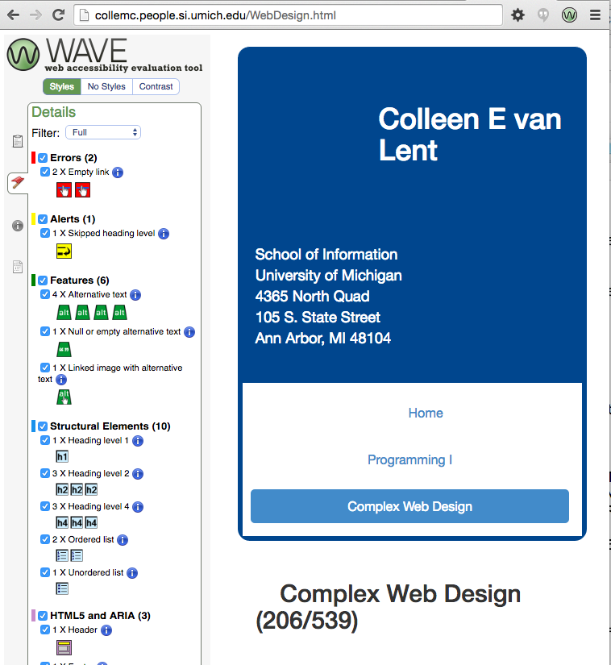

What would you do to address these problems?

You can refer to Weeks Three and Four of the Responsive Design course if you would like to review some of the things you can do with the Bootstrap framework. I only touch on a few of the options though, so the official website is a better source: <http://getbootstrap.com/>

PS

Thinking about using Bootstrap 4 instead of Bootstrap 3? That would definitely count as an "extra" for your portfolio.

# Building your site from scratch

Do you want to create the bulk of your project from scratch? This is the option for you. Students will design and style their site without the help of a blueprint or template. While it is likely they may add some plug-ins (a google map, a carousel, etc.) the bulk of the code will be their own original work. In all honesty, **the sites created using this option may appear to be less impressive than other options**, but there is a huge opportunity for learning.

In order to fulfill the requirements you will need to write your own media queries so make sure you review that topic before you get started. Feel free to head back to the entire Responsive Design course, or just these two videos that addressed media queries directly.

Media Queries: <https://www.coursera.org/learn/responsivedesign/lecture/b2Gan/>

Media Queries Part Two: <https://www.coursera.org/learn/responsivedesign/lecture/TK4CK/>

I am excited to see how many students utilize this option.

# Building your site from a template

Another option for your portfolio is to use a pre-existing template. Lets be honest, if you want a webpage there is no reason to create it from scratch if there is existing code you can utilize. The challenge in using a template will be that you need to make sure that you can modify the code to make sure it works for your content **AND** my requirements (the code needs to pass the w3 validator as well as be responsive.) If you choose this option you will need to include a small write-up describing the changes you made from the original code.

Would you like an example?

## Example One:

Template: <http://www.templatemo.com/live/templatemo_446_boxer>

Modified site: <http://winespto.org/>

But....look at the errors that would need to be fixed: <https://validator.w3.org/nu/?doc=http%3A%2F%2Fwinespto.org%2F>

## Example Two:

Template: <http://htmlcoder.me/preview/worthy/v.1.0/>

Modified site: <http://www.intro-webdesign.com/> (Look familiar?)

In this example there were a lot more structural changes since the template didn't exactly match what I was looking for.

If you would like a little more of a refresher, here is a link to a lecture on templates from the Responsive Design course: <https://www.coursera.org/learn/responsivedesign/lecture/bnAQy>

# Building your site using a framework

The third option is to use an exiting framework such as Bootstrap. This option combines the creative aspects of the scratch option and the structured approach of the template option. You do NOT need to use Bootstrap, you can choose any framework that you would like. You can find a list of possible alternatives here: [http://modernweb.com/2014/02/17/8-bootstrap-alternatives/.](http://modernweb.com/2014/02/17/8-bootstrap-alternatives/) Of course you are free to utilize other options as well.

I want to let you know that many of my students choose the framework option, but struggle getting some of the code to adhere to proper standards. In your project you will need to make sure that you adhere to the w3 and wave validators. The reason that I am sharing this with you is to help you pick a realistic layout for your work.

Example One:

In this example Bootstrap 3 is used.

The site: <http://collemc.people.si.umich.edu/WebDesign.html>

Make sure to resize the page to check out the responsive design. I have also utilized the Bootstrap carousel. There are issues though with validation and accessibility.

# Previous Week One Office Hours

Hello Everyone,

Here are my online office hours from:

June 14 (Week One): <https://www.youtube.com/watch?v=2RMNhpZQg0M>

Please note that there may be changes between earlier versions of the course and now, but hopefully many of the topics are still relevant to you.

# Extra Resources

As this course repeats I will maintain a collection of recommendations and resources that come up in the forums or previous office hours.

Here is a list of suggestions from previous students.

* Color Schemes: <https://coolors.co/>
* Images/Icons: <https://thenounproject.com/>, <http://fontawesome.io/> (this is covered in a later lecture)
* Creative Commons: <https://creativecommons.org/>
* Fonts: <https://www.fontsquirrel.com/,> <http://www.dafont.com/>